35.5: For constructive interference, we need
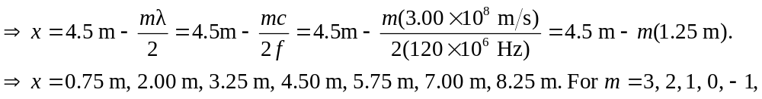
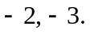 (Don’t confuse this m with the unit meters, also represented by an “m”).

